GOAT PET DIARY 2020
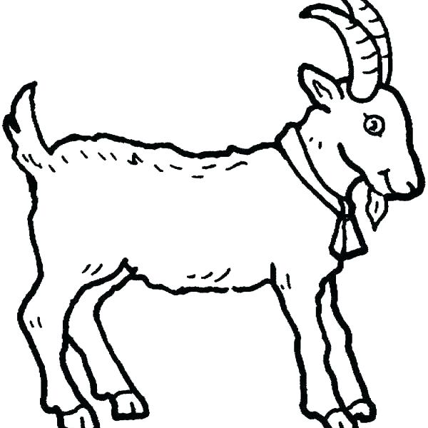

INFORMATION
Name
_____________________________
Age
___________________
Address
_______________________________
School
__________________________________

My Goat’s Name
_____________________________
Breed
__________________________________
Birth Date __________________________________

My Goat is a boy/girl
We found my goat / I got my goat from another farm.
My Goat was a single, twin or triplet
TRAINING TIPS
You will need to train your goat to walk forward beside you, to turn, and to stop to get ready for pet day.
Coming to your Call
When teaching your pet goat to come to you teach it with treats, each time you call it to come either give it is normal milk or give it another treat and give it lots of pats.
Leading
Put a small dog collar on your goats’s neck and attach a dog lead. When you want your goat to move forwards with you start walking and pull softly on the lead, when your goat takes a step forward give it a treat. Repeat doing this until your goat understands what you are trying to do.
Stopping
When you want to stop your goat gently pull on the lead rope and remember to practice standing still as well. Make sure you don’t yank on the lead too hard as this will scare your goat and will hurt its neck.
Tying Up
You can also teach your goat how to tie up. Just tie the lead around a post, when your goat stands there quietly reward it with a treat or take it away for a walk or back to its pen.
Keep it Fun
Remember to keep training fun, praise and pat your goat lots and give it treats when it does things right, keep training short so you both don’t get tired and bored.
WEEK 1 - what my goat has been doing.

What have you called your goat? Make sure it has had colostrum from its mother, if not you will either need to buy some or get from a dairy farmer. Before your goat gets home, make sure you have a safe pen with shelter, clean water, fresh grass, milk and a bottle & teat.
________________________

________________________
________________________
________________________
________________________
________________________
WEEK 2 - what my goat has been doing.

Is your goat feeding well? Put a collar on your goat and start teaching it to lead for a short time after school each day. Make sure you pat it lots and brush it so it becomes your friend.
________________________

________________________
________________________
________________________
________________________
________________________

WEEK 3 - what my goat has been doing.

Can your goat lead and tie up yet? Check its collar isn’t too tight now it has grown
________________________

________________________
________________________
________________________
________________________
________________________
WEEK 4 - what my goat has been doing.

Are you leading yourgoat everyday and walking in different patterns? Can you stand still with your goat? Get Mum & Dad to come and pat your goat and pretend to be the judge at pet day for you to practice.
________________________

________________________
________________________
________________________
________________________
________________________

WEEK 5- what my goat has been doing.
Are you getting pretty good at leading now?
Make sure you only brush your goat or wash with water, don’t ever use shampoo on your goat as this will make its coat no longer waterproof.
________________________

________________________
________________________
________________________
________________________
________________________
WEEK 6 - what my goat has been doing.

What is your favourite activity to do together?

________________________

________________________
________________________
________________________
________________________
________________________

