AUTUMN FUNDRAISER with SPRING BULBS
Help us grow by beautifying your garden

Fundraising for RAI VALLEY AREA SCHOOL playground extensions.

Here is a great opportunity to purchase spring flowering bulbs and seeds to show your support. Bulbs are easy to plant, fun to grow and will reward you with gorgeous flowers year after year. We have some great choices here, why not try them all!
Bulbs are supplied by GardenPost which source bulbs from New Zealand's best growers.
Prices offered here are less than normal retail and your organisation will make a 30% profit on all sales.
A planting guide will be enclosed with each order.

To order, return this form with payment no later than 20th March 2019. Delivery will approx. end of March

Thank you for supporting this fundraiser. Enquiries to Renee Jope 0277750083
----------------------------------------------------------------------------------------------------------------------------------------------------------------------------------------------------
BULB ORDER FORM 2019
Name:__________________________________________
Address:_________________________________________
Phone Number:____________________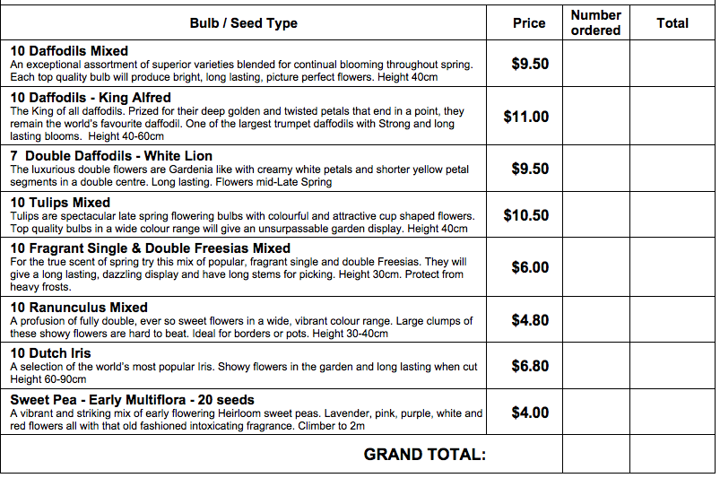
Please make payment either by cash (with order) or internet banking to:
RVAS 12-3165-0348666-000 Ref: 1185 BULBS and your NAME
THANK YOU☺☺☺ Internet Banking ▢ Cash enclosed ▢

